**MAT 3312 Homework 4 Spring 21 (Computing Assignment)**

**Name:________________ Date:________________**

**Due by 12:40pm March 31st You will only have one attempt to upload. This assignment requires SAS.**

**Import the NIFED dataset in to SAS and use the data to answers the questions below.**

A clinical trial was conducted to test the efficacy of nifedipine, a new drug for reducing chest pain in patients with angina severe enough to require hospitalization. The duration of the study was 14 days in the hospital unless the patient was withdrawn prematurely from therapy, was discharged from the hospital, or died prior to this time. Patients were randomly assigned to either nifedipine or propranolol and were given the same dosage of each drug in identical capsules at level 1 of therapy. If pain did not cease at this level of therapy or if pain recurred after a period of pain cessation, then the patient progressed to level 2, whereby the dosage of each drug was increased according to a prespecified schedule. Similarly, if pain continued or recurred at level 2, then the patient progressed to level 3, whereby the dosage of the angina drug was increased again. Patients randomized to either group received nitrates in any amount deemed clinically appropriate to help control pain. The main objective of the study was to compare the degree of pain relief with nifedipine vs. propranolol.

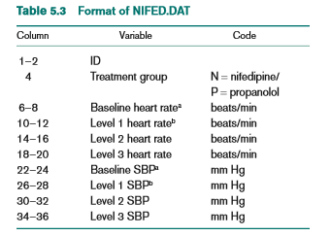

Assess whether there is any difference between the nifedpine and propranolol groups regarding their effects on average level 2 blood pressure**. Use this test question to answer questions 1-10**

**Question 1:** What is the null and alternative hypothesis?

**Question 2:** What is the mean of nifedpine?

**Question 3:** What is the mean of propranolol?

**Question 4:** What is the mean difference in between nifedpine and propranolol?

**Question 5:** Are the variance equal or unequal?

**Question 6:** What is the t-test statistics?

**Question 7:** What is the p-value?

**Question 8**: What is the conclusion?

**Question 9**: Attached results from SAS (copy and paste)

**Question 10**: Paste your code used to answer the questions above.

Assess whether there is any difference between the nifedpine and propranolol groups regarding their effects on the average level 3 heart rate**. Use this test question to answer questions 10-20**

**Question 11**: What is the null and alternative hypothesis?

**Question 12**: What is the mean of nifedpine?

**Question 13**: What is the mean of propranolol?

**Question 14:** What is the mean difference in between nifedpine and propranolol?

**Question 15:** Are the variance equal or unequal?

**Question 16:** What is the t-test statistics?

**Question 17:** What is the p-value?

**Question 18:** What is the conclusion?

**Question 19:** Attached results from SAS (copy and paste)

**Question 20:** Paste your code used to answer the questions above code.